

EMPLOYEE SELF SERVICE SYSTEM

INTRODUCTION

In this section you will learn the necessary background information to be able to complete the milestones of this case study. This information includes a history of the business, a description of the business’s current facilities, and the descriptions of the problems that triggered the project.

Case Background
A-1 Information Systems (IS) headquartered in Orlando, Florida, employs approximately 4,100 employees throughout the United States. A-1 IS provides leading edge technologies, distributed computing, mainframe, micro, communication, and consulting services to its parent company A-1 Corporation, headquartered in Bethesda, Maryland, as well as to external customers including the U.S. government. In addition A-1 IS is responsible for the development and support of all the internal systems that support their day-to-day business processes and operations.
A-1 IS currently operates in five sites across the nation and they are as follows:
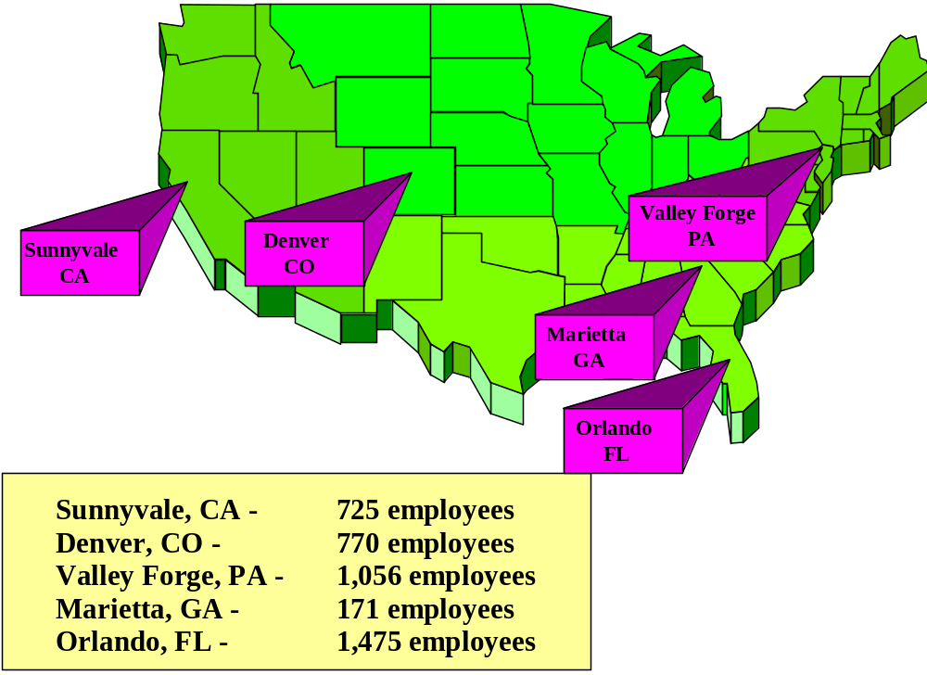

Each site is responsible for servicing and supporting the customers in its region as well as its internal employees.
A-1 IS has experienced a 15 percent increase in employees over the past two years, and long-range projections show that trend continuing for the next three years.

Organization Structure

A-1 Information Systems

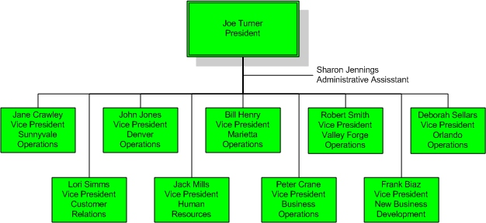

Information Systems Facilities
The information architecture for A-1 IS uses the following standards:
- Desktop PC— IBM ThinkCentre S series
Pentium 4 processor
512 megabytes of RAM
80 GB disk drive
17 or 19 inch monitors
Operating system — MS Windows XP Pro
Standard Tools — MS Office suite (2003)
Internet Browser — IE 6
Virus Protection — Norton AV
E-mail — MS Outlook
- Servers — IBM xSeries 336
Intel Xeon processor
4 GB of RAM (16GB in Orlando)
200 GB in hard disk storage (via RAID 5 configuration)
Operating system — MS Windows Server 2003
Database Management System — Oracle 10g
- Printers — Hewlett Packard LaserJet and PaintJet classes.
- LAN – Each office employs a wired and wireless Ethernet LAN
- WAN – A VPN connects each office to the main office in Orlando

*** Notes:
Each site has comparable hardware and software, and the employee to micro ratio is 1-to-1.

Many employees, including most managers, use IBM notebooks with docking stations as their desktop computer. Each notebook is comparable to Gateway desktop specifications.

The Problem
Due to the tremendous growth the company has experienced in recent years, it has recognized that to ensure the continued success of servicing internal as well as external customers, it needed to develop a strategic plan and vision for the use and modernization of its computing resources. The challenges of creating centralized systems across all five IS sites to support business practices that are common if not identical across the sites further emphasize the need.

In January 2005 a strategic plan to modernize the company’s resources was presented to executive management. This document included a multi-phased plan to reengineer the current systems to use state-of-the-art technology and to provide a showcase of systems that eventually could be delivered across the whole corporation.

Phase 1 of the plan consisted of reengineering all systems related to Human Resources, which included employee information, time and attendance, and payroll. Task 1 of this phase is the development of the Employee Self-Service System (ESSS), a system that will house the repository of employee master data. This system would provide the capability for each employee to maintain his or her own information regarding address and telephone numbers, emergency contact information, payroll deduction options, and savings bond purchases.

Current practices now have each of these changes being processed by an extensive manual effort in which Human Resource administrators fill out forms and input the data. This manual effort often results in a time lag of several days between the time the employee submits the forms and the update of the information in the computer. This delay has caused several problems, including unacceptable lag time in implementing payroll deduction changes and company mailings (including pay checks) being sent to the wrong address. Another problem of the present system is the employee directory, which is printed every six months. It seems to be out-of-date as soon as it arrives with missing information on new employees, and incorrect information on employees who have changed addresses or been transferred.

The plan for the new system is to provide the capability for an employee to update data themselves in real time, the problems mentioned above can be reduced, if not eliminated. The printed employee directory will be replaced by an intranet-based online directory that will be driven by the ESSS database and always up-to-date.

